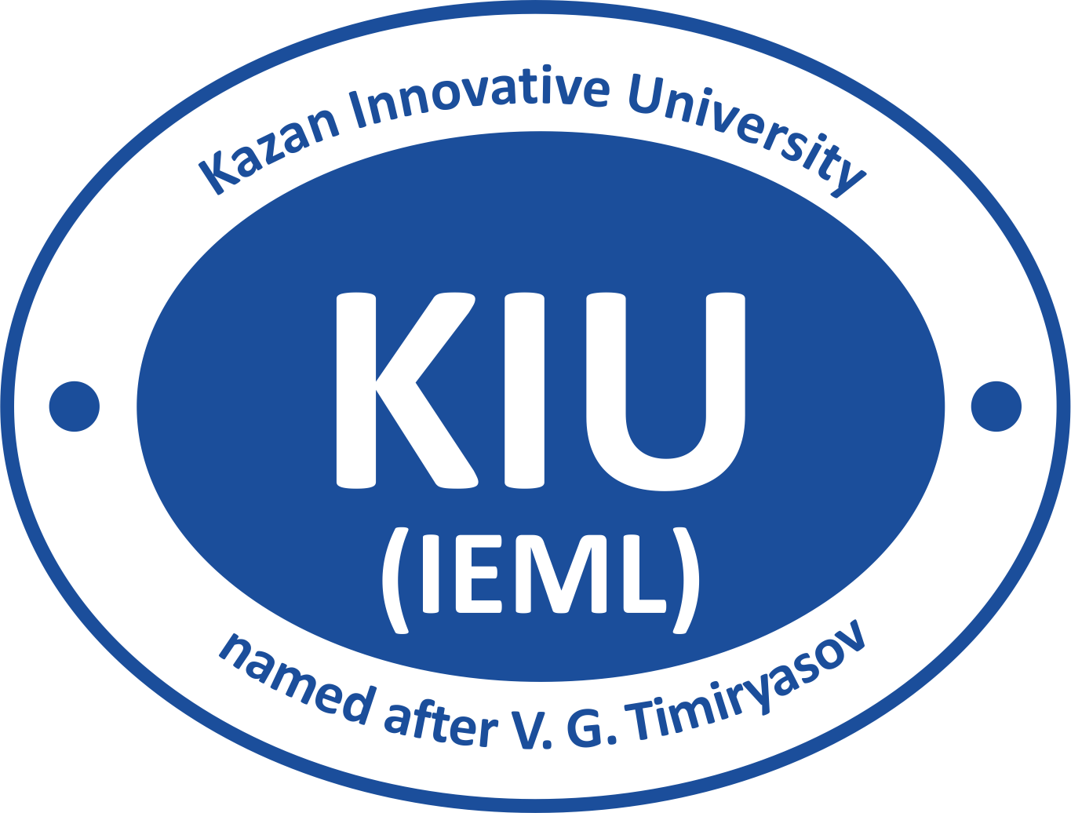

APPLICATION FORM
for foreign applicants of Kazan Innovative University named after V.G. Timiryasov (IEML)

PERSONAL DATA
Full Name:___________________________________________________
Gender: male female Marital Status:_______________
Date of Birth: Nationality:
National passport No.: Date of Issue: Date of Expire:___________
Present Address:
Permanent Address:
Contact No.: Contact E-mail:

EDUCATIONAL BACKGROUND

SCHOOL
Received level: _________________________________________________

COLLEGE / UNIVERSITY
Received degree: ________________________________________________
Faculty/Specialization: ___________________________________________
Attended Since_________till________

Have you studied in Russia before? yes no (If “yes” specify the year, course and university name)_______________________________________
Have you ever studied the Russian language? yes no (If “yes” specify when and where)__________________________________________

FUTURE EDUCATION
Proposed Degree program: Bachelors Masters Ph.D/PG
Speciality / Field of study:________________________________________
Proposed University: ____________________________________________
1st choice: ________________________________________________
2nd choice: ________________________________________________

I agree I have to run 1 year Russian Language Preparatory Program to continue education at Russian universities.

I choose the following option of Russian Language Preparatory Program (choose only 1):
Russian language as foreign (2300$);

Russian language + professional module (preparation for entrance exams of higher education) (2500$).

Acquaintance with studying rules in Russia

Entering a Russian language course:
- scan of passport;
- scan of a document about your previous education;
- payment certificate (30% from the whole price).

According to the law of the Russian Federation “Concerning the rules of international citizens staying on the territory of the Russian Federation” students that finish Foundation Program of Intensive Russian Language Course and apply for BA/MA/PhD degree programs MUST leave the Russian Federation to get a new visa in the home country or any other country.

Entering Russian universities:
- certified translation of the passport in the Russian Language (at the Embassy of the Russian Federation in your country);
- legalized documents of your previous education (documents should be legalized in the Embassy of the Russian Federation/Ministry of International Affairs in your country – the procedure is called “Embassy legalization”/ “Apostile”);
- certified translation of legalized/apostiled documents of school education in the Russian Language (at the Embassy of the Russian Federation in your country);
- signed agreement;
- payment certificate;
- medical certificate, confirming a student hasn’t death diseases and infections;
- certified translation of the medical certificate, confirming a student hasn’t death diseases and infections (in the Embassy of the Russian Federation in your country).
- successfully passed exams in the Russian language and other subjects (selection of subjects depends on what you are going to study on a degree program. Find out what subjects you need to pass in advance, better one year before in order to pass them successfully).

Studying rules:
- attendance of classes is obligatory in Russia (exception in case of sickness, but you need to inform your teacher/international office about it in advance);
- if you are late more than for 15 minutes your teacher has a right not to allow you to come in;
- in order to be allowed to pass an exam in the Russian language and other subjects you need to get a minimum of points, which you get due to your attendance of classes, doing your homework and a good work during classes;
- in Russia students study from Monday to Saturday, be ready to have classes on Saturdays;
- studying either at Russian universities or at the Russian language course is held on in the Russian language only;
- in Russia an academic year starts only once in a year and it’s in SEPTEMBER (for degree programs).

Accommodation rules:
Students must:
- return to a dormitory before 11 p.m. (The dormitory closes from 11 p.m. to 6 a.m.). If you go to a party/night club, we recommend you to stay at your friend’s house, a club or at a hotel. Don’t walk on streets late at night;
- take part in duties (1-2 times in a month each room is responsible for cleaning in the kitchen) + attend a big cleaning up for all (Russian and foreign) students;
- wash the dishes and clean the kitchen after cooking;
- respect the dormitory administration and follow their requests;
- keep order in rooms.
Students mustn’t:
- drink/smoke/spend night in another room/make noise after 9 p.m/bring guests (without informing and getting allowance of the dormitory administration).
Punishment for violation is: the first – warning, the second – departure from a dormitory.
Dormitory must:
- respect students;
- provide bed sheets and necessary help;
- check rooms whether they are clean once a week.

I’m informed about all rules connected with my staying and studying in Russia.
I’m informed that I must leave Russia after completion my Russian language course to get a new visa in case of continuing education in Russia.

Date:___________________ Applicants Signature:________________

